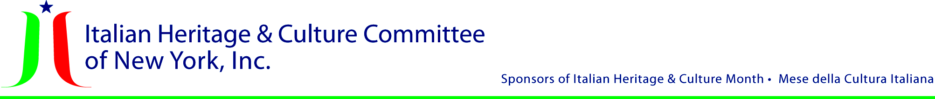

Founding Chairman
Gran. Uff. Angelo Gimondo, Ph.D.*

Honorary Chairpersons
Min. Plen. Fabrizio Di Michele
Consul General of Italy in New York
Prof. Fabio Finotti
Director, Italian Cultural Institute, New York
Christopher Loiacono
President, Columbus Citizens Foundation
Cav. di Gr. Cr. Hon. Dominic R. Massaro
Justice, NYS Supreme Court
Uff. Joseph V. Scelsa, Ed.D.
President, Italian American Museum
Cav. Anthony Julian Tamburri, Ph.D.
Dean, John D. Calandra Italian American
Institute, Queens College/CUNY

President and Chairman
Comm. Joseph Sciame
Vice President
Maria C. Marinello, Esq.
Secretary
Elisabetta Calello
Treasurer
John Mustaro, P.E.

Committee Chairs
Marketing
Rosa Casiello O’Day
Membership
William Russo
Programming
Cav. Joan Marchi Migliori
Public Relations
Nancy J. Indelicato
Special Projects
Cav. Giuliana Ridolfi Cardillo

Legal Advisor
Josephine Belli, Esq.

Board of Directors
Uff. George Altomare*
Claudia Massimo Berns
Claudia Carbone, Esq.
Dott.ssa Antonella DeGennaro
Joseph DiPietro
Uff. Maria Fosco
Barbara Gerard, Ed.D.
Jennifer Adriana LaDelfa
Uff. Mico Delianova Licastro
Prof. Lucrezia Lindia
Cav. Josephine A. Maietta
Cav. Dott. Berardo Paradiso
Cav. MaryAnn Re, Ph.D.
Mark Rotella
Ferdinand Visco, M.D.

Board of Advisors
Gr. Uff. Silvana Mangione
Stephen R. Aiello, Ph.D.
Stefano Albertini, Ph.D.
Cav. Anthony Brusco
Louis Calvelli
Giuseppe Cirnigliaro, J.D.
Rosanna Coscia
Gaetano Cipolla, Ph.D.
John Battista De Santis
Cav. Prof. Mario Fratti*
Frances Fusco
Rosa Ricco Pietanza
Wanda Radetti
Cav. Angelo Siciliano

*Deceased

6.15.23

Rev. 3.2.21

Rev. 3.2.21

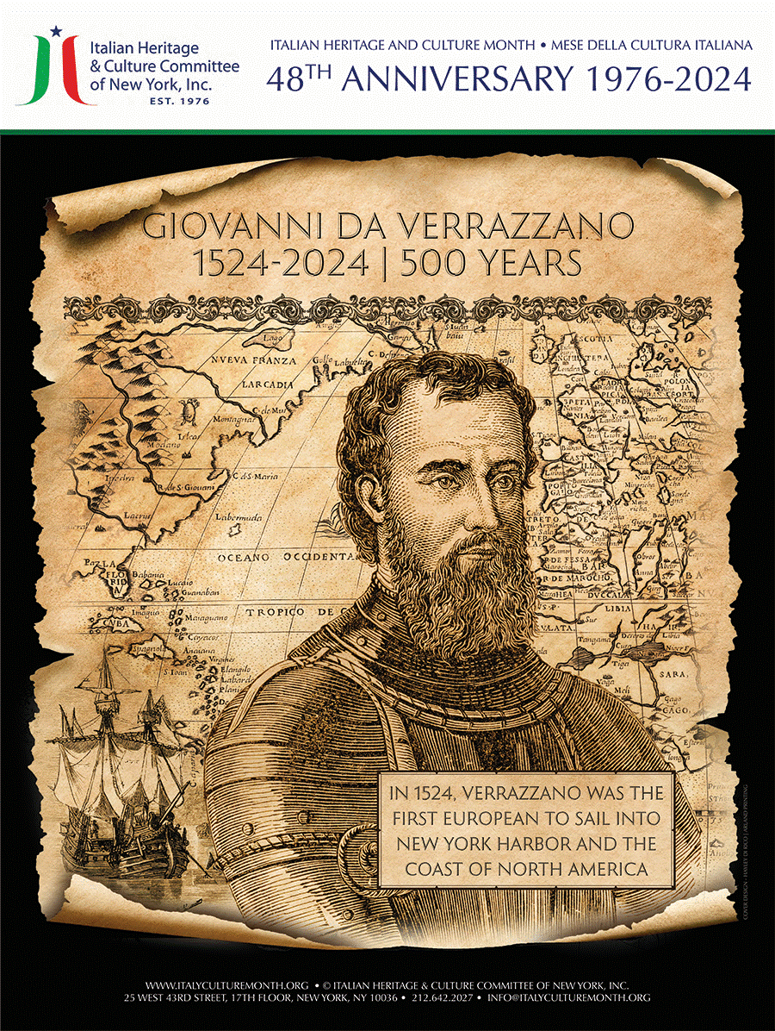
9/30/2024
Since 1976, the Italian Heritage and Culture Committee of New York, Inc. (IHCC-NY, Inc.) has spearheaded first a week, and now a month-long collaboration with other Italian and Italian American organizations, with the mission of promoting, presenting and preserving Italian and Italian American culture in the Tri-State area. Its annual theme is mirrored by other states in their event programming throughout America.
This year’s theme is Giovanni da Verrazzano, the Renaissance Explorer and Humanist, who while attempting to find a route to the East, became the first European to enter New York Bay on April 17, 1524, 500 years ago and 85 years before Hudson! He came not as a conqueror, or colonizer, but as an observer. His inquiring mind mapped the entire eastern coast of America from Florida to New Foundland. He described the topography, climate, and the Native Indians with whom he remained for several weeks, learning about their culture, which is preserved in a letter he wrote to his sponsor, King Francis l of France. A rare copy of this Cellere Codex is in the Morgan Library in New York. Also, November 21 marks the 60th Anniversary of his namesake, the Verrazzano-Narrows Bridge.
During the year the IHCC-NY hosts, coordinates or publicizes, theme related presentations, symposiums, seminars, proclamations at every level of government, along with the IHCC-NY’s highest honor, the Leonardo da Vinci award. Comm. Joseph Sciame, President/Chair of the IHCC-NY, Inc. recently commented with regard to the Verrazzano celebration: “We have a special person in Verrazzano this year, for he was a man of his times, and cared for the people he met, and his arrival in our New York Harbor is a piece of important history for us and the world.” Each year the Proclamations of the President and Congress of the United States honor the achievements and contributions of Italian immigrants and their descendants living in the United States, particularly in the arts, science, and culture.
Annually, a thematic IHCC-NY, Inc. Student Essay Contest is held and chaired by Board member Lucrezia Lindia. Judges include other Board members: Giuliana Ridolfi Cardillo and Claudia Massimo Berns (Italian) Maria Marinello and Nancy Indelicato (English), and the following are the winners of the 2024 IHCC Essay Contest: Italian Competition: Jonathan Shim, grade 11, Cresskill High School, NJ, submitted by Ms. Diana Zoino. English Competition: Grade 9 Grace Abraham, Preston High School, NY, submitted by Miss Rosemary DeMaio; Grade 10 Maria Iodice, Millburn High School, NJ, submitted by Ms. Valeria Luppino.
The Committee’s publicly supported educational materials, including theme related posters, bookmarks and booklets, continue to be distributed free to educational, cultural and public institutions, ensuring the Committee’s ongoing education of the general public about the merits of Italian/Italian American heritage and culture.

Contact: Nancy Indelicato
Chair, Public Relations
naindel@hotmail.com
646-499-1834

251659264
For Immediate Release

Italian Heritage & Culture Committee of New York, Inc.
25 West 43th Street, New York, N.Y. 10036 • Tel 212.642.2094 • Fax: 212.642.2030
www.italyculturemonth.org • info@italyculturemonth.org
Celebrating 500th Anniversary of Verrazzano’s Discovery
of
New York Harbor
and
Verrazzano-Narrows Bridge 60th Anniversary
Uff. Joseph Sciame
President/Chair

